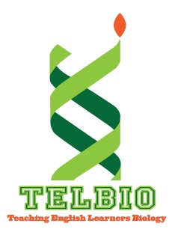
TELLING BIOLOGY TEACHER’S GUIDE

Episode 1: Worms

STANDARDS:
The following standards may be addressed by using the podcast in conjunction with the information provided in the Teacher’s Guide:

Provide NGSS standards and common core standards that connect to the story and/or the information/ activities provided in the Teacher’s Guide.

BACKGROUND:
Provide some background for the science/ biology concepts that are discussed in the podcast. The podcast itself should be under 10 minutes, and is not intended to get into the details of the content, rather, it is a “jumping off spot”. This guide provides more detailed background on the biological content that the podcast can help to illustrate, and the teacher can use this background at whatever level s/he feels is appropriate.

ACADEMIC LANGUAGE:
Pick some key words/ concepts that the podcast can be used to help illustrate. Remember, these can be content words OR science process words (like evaluate, analyze, justify, etc.) It may be true that the story provides more of an emphasis on what science is about, or what it is like to “do” science, but many of these science process words are used differently in science than in “everyday” language, so it helps to draw out these meanings.

THINGS TO THINK ABOUT:
Come up with some open-ended questions that students could pursue that are related to the concepts or the processes related to the story in the podcast. This section can be combined with academic language if it seems appropriate.

REFERENCES:
Provide references for the resources you used to prepare the Teacher’s Guide in APA format. Consider including references that students could use to pursue the topic further as well.

